**Project Structure**

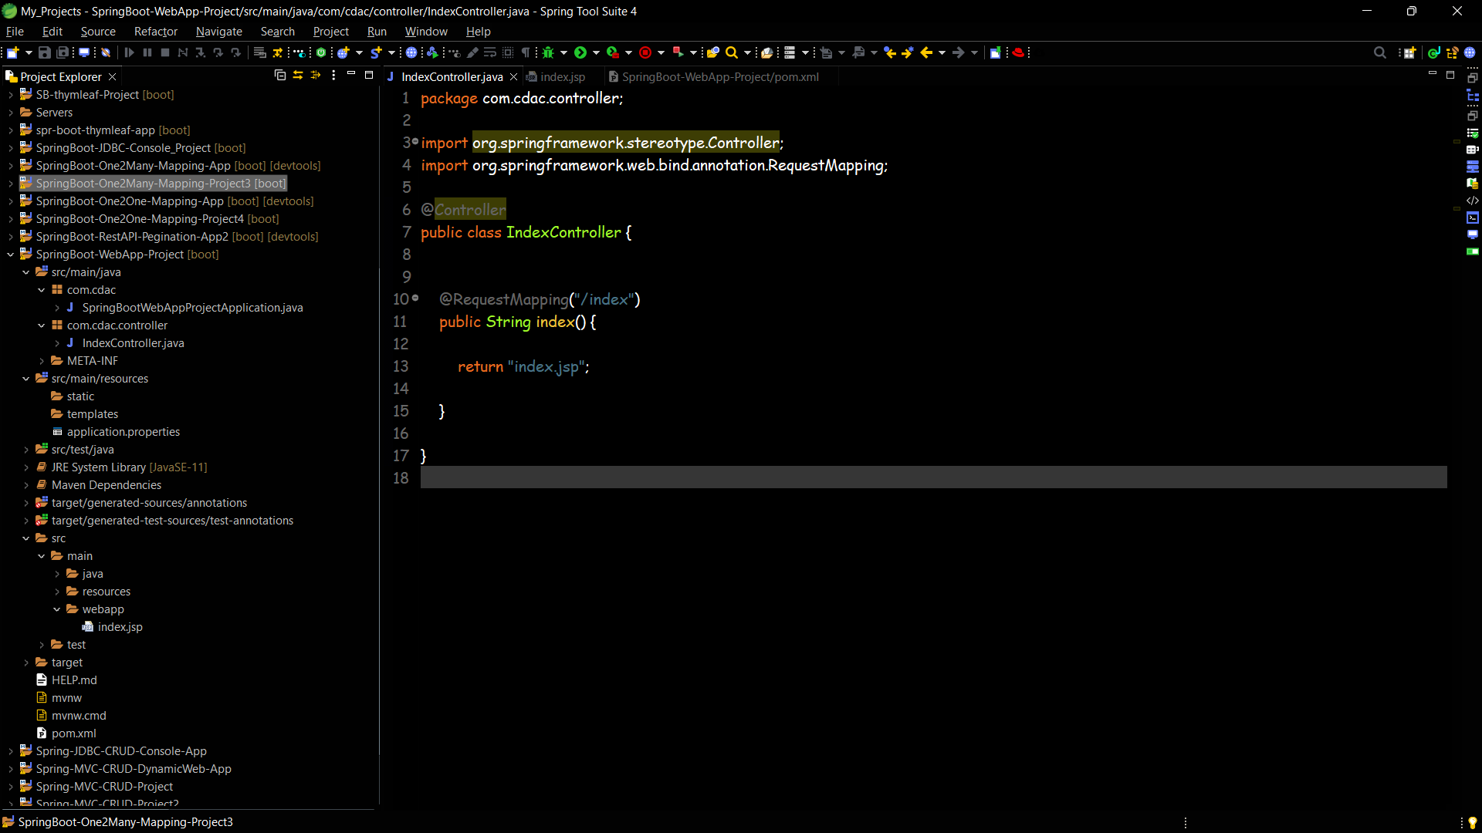

**Pom.xml**

<?xml version="1.0" encoding="UTF-8"?>

<project xmlns="http://maven.apache.org/POM/4.0.0" xmlns:xsi="http://www.w3.org/2001/XMLSchema-instance" xsi:schemaLocation="http://maven.apache.org/POM/4.0.0 https://maven.apache.org/xsd/maven-4.0.0.xsd">

<modelVersion>4.0.0</modelVersion>

<parent>

<groupId>org.springframework.boot</groupId>

<artifactId>spring-boot-starter-parent</artifactId>

<version>2.7.10</version>

<relativePath /> <!-- lookup parent from repository -->

</parent>

<groupId>com.cdac</groupId>

<artifactId>SpringBoot-WebApp-Project</artifactId>

<version>0.0.1-SNAPSHOT</version>

<name>SpringBoot-WebApp-Project</name>

<description>Spring Boot Project</description>

<properties>

<java.version>11</java.version>

</properties>

<dependencies>

<dependency>

<groupId>org.springframework.boot</groupId>

<artifactId>spring-boot-starter-web</artifactId>

</dependency>

<dependency>

<groupId>org.apache.tomcat</groupId>

<artifactId>tomcat-jasper</artifactId>

<version>9.0.73</version>

</dependency>

<dependency>

<groupId>org.springframework.boot</groupId>

<artifactId>spring-boot-starter-test</artifactId>

<scope>test</scope>

</dependency>

</dependencies>

<build>

<plugins>

<plugin>

<groupId>org.springframework.boot</groupId>

<artifactId>spring-boot-maven-plugin</artifactId>

</plugin>

</plugins>

</build>

</project>

**IndexController**

package com.cdac.controller;

import org.springframework.stereotype.Controller;

import org.springframework.web.bind.annotation.RequestMapping;

@Controller

public class IndexController {

@RequestMapping("/index")

public String index() {

return "index.jsp";

}

}

**Index.jsp**

<%@ **page** language="java" contentType="text/html; charset=ISO-8859-1"

pageEncoding="ISO-8859-1"%>

<!DOCTYPE html>

<html>

<head>

<meta charset="ISO-8859-1">

<title>Home page</title>

</head>

<body>

<div align="center">

<h1>Welcome to my Spring Boot Web Application...</h1>

</div>

</body>

</html>

**SpringBootWebAppProjectApplication.java**

package com.cdac;

import org.springframework.boot.SpringApplication;

import org.springframework.boot.autoconfigure.SpringBootApplication;

@SpringBootApplication

public class SpringBootWebAppProjectApplication {

public static void main(String[] args) {

SpringApplication.run(SpringBootWebAppProjectApplication.class, args);

}

}

**Web Browser Output Screenshot**

